**BANKING APPLICATION & ZOO MANAGEMENT SYSTEM**

**(ASSIGNMENT # 2 SEMESTER FALL-2023)**

**Submission Date (Oct 25, 2023)**

**By**

**MUHAMMAD IBTISAM AFZAL**

**Registration No.**

*FA22-BCS-073*

**Course Code (Course Title)**

*CSC241 (Object Oriented Programming) - Lab*

**Degree Program Title and Section**

*BCS-B*

**Submitted To**

*Mr. Shafqat*

**Department of Computer Science**



**COMSATS UNIVERSITY ISLAMABAD, SAHIWAL CAMPUS**

**Task 1:** Imagine you are developing a banking application. You have a base class **Account** that includes properties like **accountNumber**, **accountHolderName**, and **balance**. There are two derived classes, **SavingsAccount** and **CurrentAccount**, which inherit from Account. In addition to the base properties, SavingsAccount has an extra property called **interestRate** for calculating interest on the account balance. Users can deposit money into both **SavingsAccount** and **CurrentAccount**. The **CurrentAccount** allows users to withdraw funds, ensuring they don't exceed their account balance and the overdraft limit. The **SavingsAccount** calculates and adds interest to the balance over time. Users can view their account information, including the account number, account holder name, current balance, and interest rate, for **SavingsAccount** or the account number, account holder name, and current balance for **CurrentAccount**.

**Source Code:**

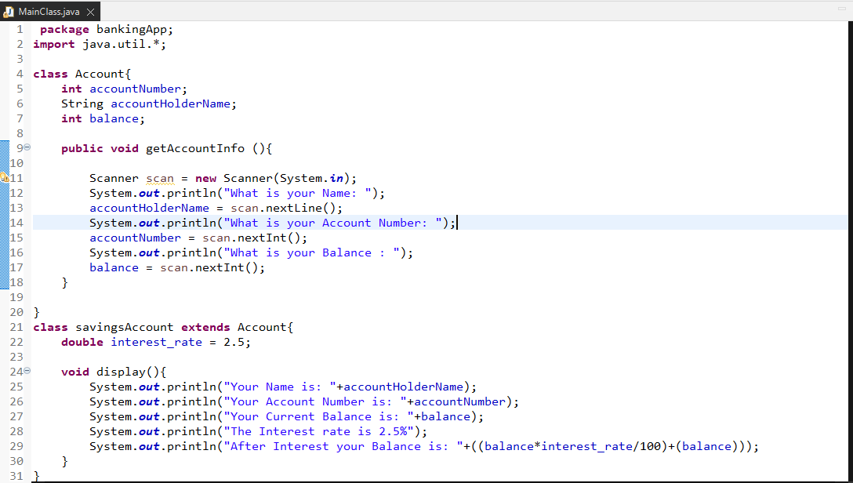

**Output:**

**For Current Account:**

**For Savings Account:**

**Task 2:** Imagine you are designing a zoo management software. You start with a base class called Animal that includes attributes like name and age. Two derived classes, Mammal and Bird, inherit from Animal. Mammals have additional properties like furColor and can perform actions like giveBirthToYoung, while Birds have properties like wingSpan and can perform actions like fly. The zoo software allows zookeepers to record and display information about the animals. For mammals, it includes details about fur color and birth records, and for birds, it shows information about wingspan and flight capabilities.

**Source Code:**

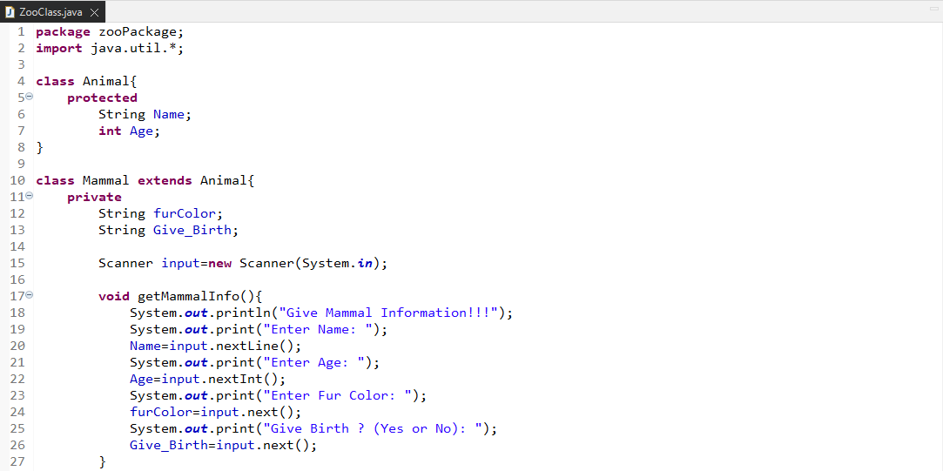

**Output:**

